CS 157A Intro to Database Management Systems

Project Data Model & DB Design Document

Project Title: Stock Data Aggregation Web-App

TEAM 34

Sachin Shah

Yang Li

En-Ping Shih

Professor: Dr. Mike Wu

TA: Sriram Priyatham Siram

San Jose State University

October 8th, 2019

**ER-Model**

For our Entity-Relationship Model diagram, we used red to represent entities, blue for attributes and green for relationships. As it shown on Figure 1 below.

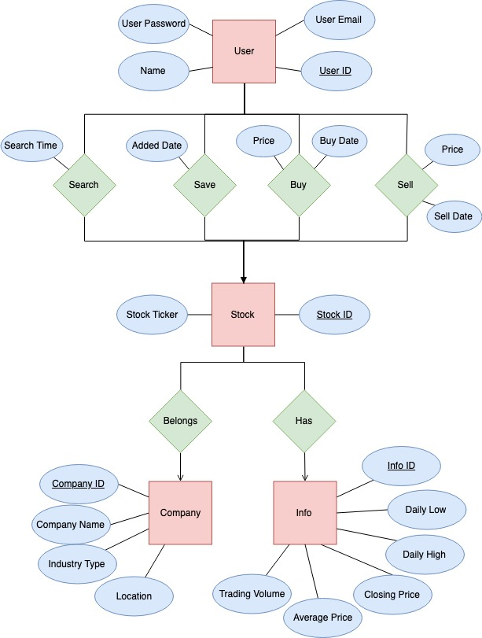

Figure 1. ER-Model

**Table**

Table 1) User (User ID, Name, User Email, User Password)

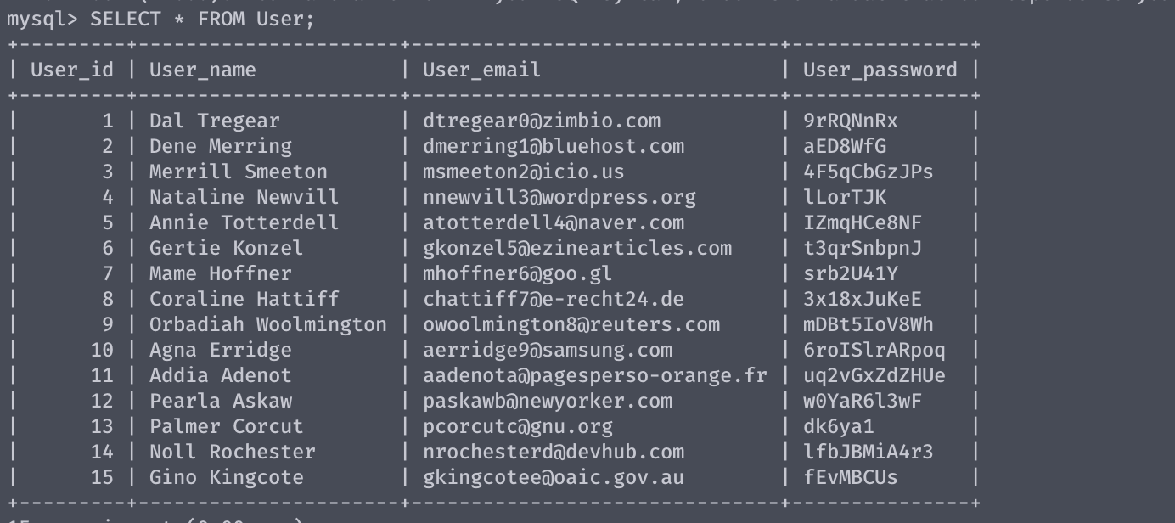There are many users of our application, and this table is an example of how that information would be stored.

Table 2) User Has (User, Favorite List, Search History, Deleted History)

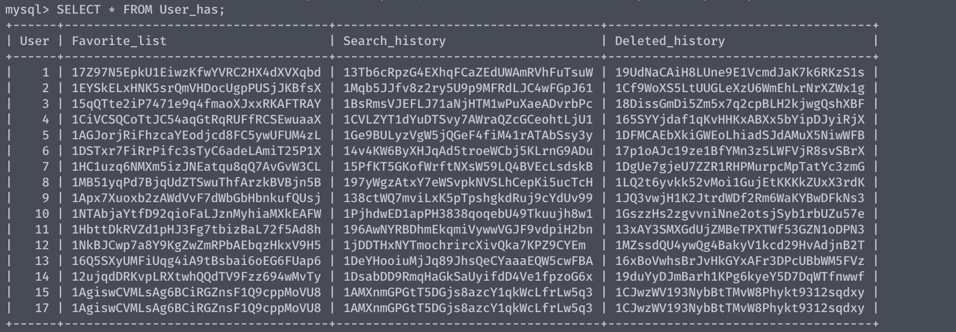Each unique user is associated with three more tables which contain the user’s favorite stocks, the user’s recent search history, and the user’s recently deleted searches.

Table 3) Search History (Stock, Search Time)

From each user’s search history list, each stock will have a timestamp of when the user have searched for the search via the search bar.

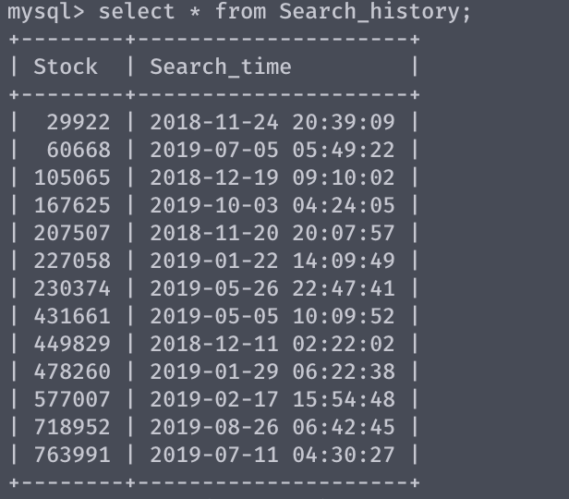

Table 4) Favorite List (Stock, Added Date)

From each user’s favorite list, each stock has a Stock ID and a timestamp of when it was added to the user’s favorite list.

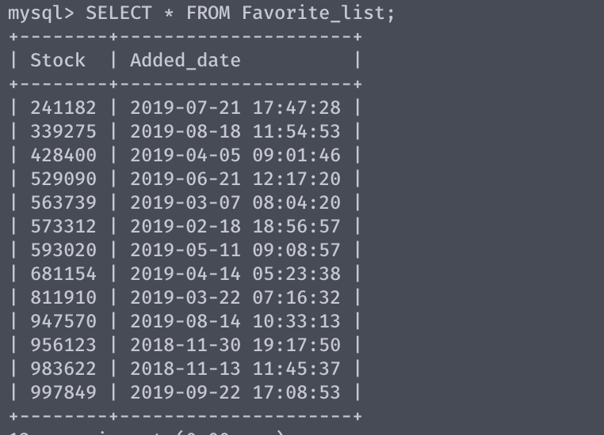

Table 5) Deleted History (Stock, Deleted Date)

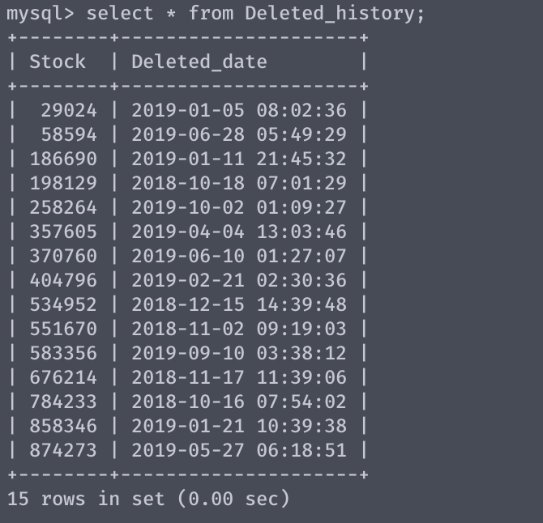Deleted history table aggregates stock objects, primary key of the relationship is the Stock ID.

Table 6) Contained (Stock, Favorite List, Search History, Deleted History)

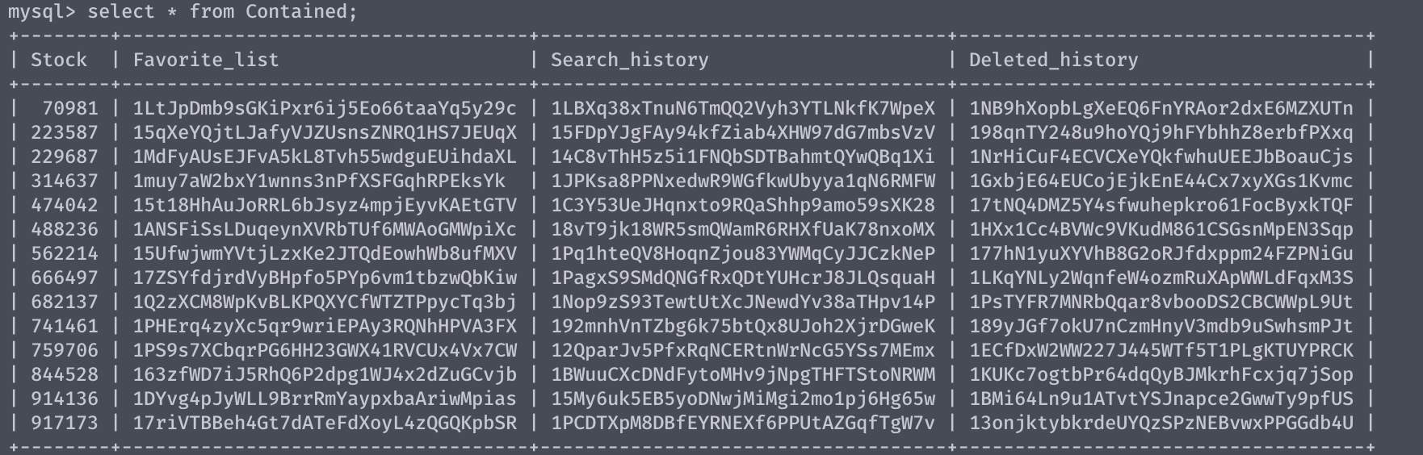In the relationship between Favorite List, Search History and deleted history, each of these tables aggregate stock objects so Stock is its own entity with attributes. In a one to many relationships, one of each of the tables mentioned can hold several stock objects.

Table 7) Stock (Stock ID, Stock Ticker)

Each Stock has a table called information associated with it, Stock ID is again the primary key of the relationship.

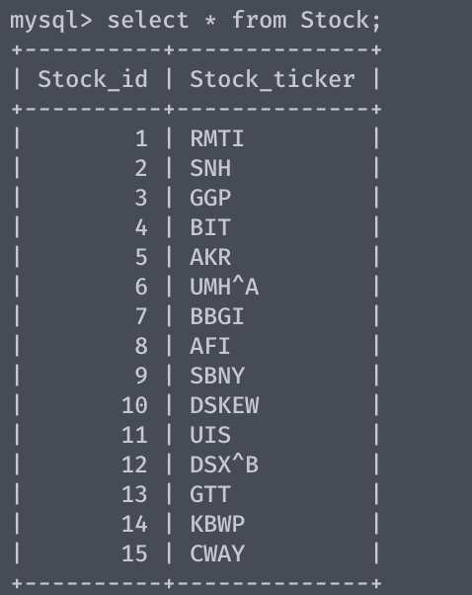

Table 8) Stock has (Stock, Info, Price)

This is a table demonstrating a join between Stock, and its two entities Information and Price.

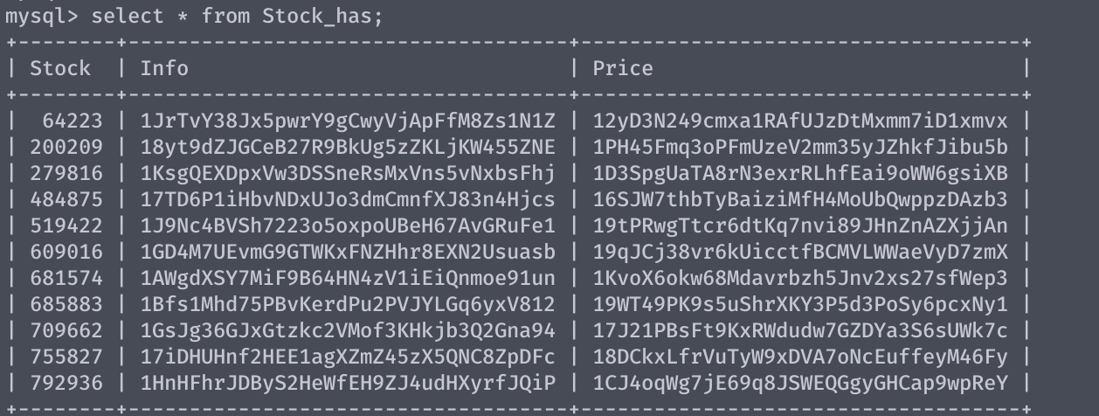

Table 9) Info (Stock, Moving Average, Trading Volume, Beta Value, Value for Buy, Value for Sell)

Each Stock has a table called information(info) associated with it, Stock ID is again the primary key of the relationship.

Table 10) Price (Stock, Closing Price, Daily Low, Daily High, Average Price)

Each Stock also has a table called price associated with it to store information about the price.

